|  |  |  |  |  |  |
| --- | --- | --- | --- | --- | --- |
| **GSE Gainers** | |  | **GSE Decliners** | | |
| **Stock** | **Cl. Px** | **Daily∆ (%)** | **Stock** | **Cl. Px** | **Daily∆ (%)** |
| GCB | 3.86 | 2.66 | -- | -- | -- |
| GLD | 322.00 | 3.07 | -- | -- | -- |
| -- | -- | -- | -- | -- | -- |
| -- | -- | -- | -- | -- | -- |
| -- | -- | -- | -- | -- | -- |

|  |  |  |  |  |
| --- | --- | --- | --- | --- |
| **Daily Statistics** | **Previous Level** | **Current Level** | **Daily∆ (%)** | **YTD (%)** |
| GSE-CI | 3,439.21 | 3,441.65 | 0.07 | +9.95 |
| GSE-FSI | 2,013.72 | 2,018.32 | 0.23 | +6.14 |
| Market Cap (GHSmn) | 77,616.08 | 77,670.42 | 0.07 | +5.11 |
| Tot. Value Traded (GHS) | 16,439,123.20 | 12,143,699.29 | -26.13 | -- |
| Tot. Volume Traded | 125,419 | 68,460 | -45.41 | -- |

**EQUITIES**

**NEWS HEADLINES**

* **Fitch Solutions predicts 3.5% growth rate for Ghana in 2024; says economy has begun recovery:** In its April 2024 Sub-Saharan Africa Macroeconomic Update, Fitch Solutions said the country’s economy will expand by 3.5% in 2024, contrary to the World Bank’s 2.9%. Senior Country Risk Analyst at Fitch Solutions, Mike Kruiniger, said the signs are clear that the Ghanaian economy has begun recovery. According to him, the primary driver of economic growth will be consumer spending, spurred by moderating inflation. Additionally, they expect trend of election induced government spending to continue which will contribute to growth, as the government will seek to improve the general well-being of the people. [(Myjoyonline)](https://www.myjoyonline.com/fitch-solutions-predicts-3-5-growth-rate-for-ghana-in-2024-says-economy-has-begun-recovery/)
* **Ghana reaches Staff-Level agreement with IMF after second review; secures $360m third tranche:** Ghana has secured $360 million from the International Monetary Fund (IMF) subject to passing the Fund’s Board Approval. The $360m will be the third installment from the Bretton Wood Institution under the $3bn Fund programme. This is in view of the attainment of a Staff-Level agreement by Ghana following the second review of the country’s extended credit facility. The IMF mission chief for Ghana added that the IMF board will need financing assurances in considering the staff-level agreement. Further, an agreement between the Ghanaian authorities and their official creditors on an MoU for a debt treatment in line with program parameters would provide the needed financing assurances. [(Norvanreports)](https://norvanreports.com/ghana-reaches-staff-level-agreement-with-imf-after-second-review-secures-360m-third-tranche/)

**FIXED INCOME**

|  |  |  |
| --- | --- | --- |
| **Summary of GFIM** | **Volume of Trades** | **No.of**  **Trades** |
| New GoG-Notes & Bonds | 200,355,287 | 5 |
| Old GoG-Notes & Bonds | 20,000 | 1 |
| Treasury Bills | 242,397,968 | 604 |
| Corporate Bonds | - | - |
| **Grand totals** | **442,773,255** | **610** |

**Treasuries Yield Curve:**

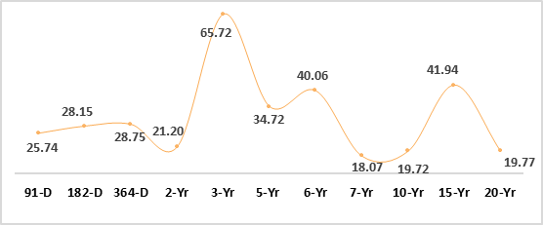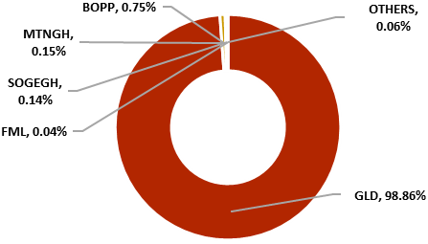

**GSE Contributors to Value**

|  |  |  |  |
| --- | --- | --- | --- |
| **Currency**  **Pairs** | **Midpoint**  **(BoG)** | **Daily∆ (%)** | **YTD∆ (%)** |
| USDGHS | 12.9867 | 0.12 | -8.52 |
| GBPGHS | 16.1782 | -0.49 | -6.46 |
| EURGHS | 13.8293 | -0.66 | -5.08 |
| CNYGHS | 1.7942 | 0.08 | -6.74 |
| ZARGHS | 0.6878 | -0.53 | -5.58 |

**Currency Movement**

Upcoming Events:

* GDP Growth Q423 – 3.8%
* Interbank Int. Rate – 28.74%

* MPR – 29.0%
* Inflation – 25.8%

Macroeconomic Indicators:

15th APRIL 2024

**MORNING BRIEF**

Disclaimer - SIC Brokerage and its employees do not make any guarantee or other promise as to any results that may be obtained from using our content. No one should make any investment decision without first consulting his or her own Investment advisor and conducting his or her own research and due diligence. SIC Brokerage disclaims any and all liabilities in the event that any Information, commentary, analysis, opinions, advice and/or recommendations prove to be inaccurate, incomplete or unreliable, or result in any investment or other losses.