|  |  |  |  |  |  |
| --- | --- | --- | --- | --- | --- |
| **GSE Gainers** | |  | **GSE Decliners** | | |
| **Stock** | **Cl. Px** | **Daily∆ (%)** | **Stock** | **Cl. Px** | **Daily∆ (%)** |
| GLD | 309.20 | 0.47 | MTNGH | 1.57 | -0.63 |
| CMLT | 0.11 | 10.00 | -- | -- | -- |
| -- | -- |  | -- | -- | -- |
| -- | -- | -- | -- | -- | -- |
| -- | -- | -- | -- | -- | -- |

|  |  |  |  |  |
| --- | --- | --- | --- | --- |
| **Daily Statistics** | **Previous Level** | **Current Level** | **Daily∆ (%)** | **YTD (%)** |
| GSE-CI | 3,464.13 | 3,451.96 | -0.35 | +10.28 |
| GSE-FSI | 2,014.81 | 2,014.81 | 0.00 | +5.95 |
| Market Cap (GHSmn) | 77,860.67 | 77,732.55 | -0.16 | +5.20 |
| Tot. Value Traded (GHS) | 7,235,367.20 | 2,829,066.49 | -60.90 | -- |
| Tot. Volume Traded | 72,309 | 145,307 | 100.95 | -- |

**EQUITIES**

**NEWS HEADLINES**

* **Gov’t raises cocoa farm-gate price by 58%; farmers to earn GHS 33,120 per ton:** Ghana has followed the Ivory Coast to raise the price it pays farmers for their produce after cocoa futures soared. The world’s second-biggest producer of the chocolate ingredient increased the farmgate price for cocoa beans 58 per cent to 33,120 cedis (US$2,481) per ton for the rest of the 2023-24 season, Ghana Cocoa Board said in a statement. That translates into 2,070 cedis per bag of 64 kilograms, it said. The Cocoa industry regulator mentioned that, the increase in the producer price of coca has become necessary to enhance the income of farmers in as well the rise in prices of cocoa on the international market. [(Norvanreports)](https://norvanreports.com/govt-raises-cocoa-farm-gate-price-by-58-farmers-to-earn-ghs-33120-per-ton/)
* **GEA grants FDA GH¢5m to enhance progressive licensing of MSMEs:** The Ghana Enterprises Agency (GEA) has contributed GH¢5million to the Food and Drugs Authority (FDA) to enhance regulatory efforts in the food and pharmaceutical sectors. This financial backing aims to fortify the FDA’s licensing initiatives, making the process more streamlined and efficient for micro, small and medium enterprises (MSMEs). The move is in partnership with the Mastercard Foundation, signifying a concerted effort to enhance the oversight and regulation of food and drug-related businesses, with priority on consumer safety and product quality. [(Business & Financial Times)](https://thebftonline.com/2024/04/08/gea-grants-fda-gh%c2%a25m-to-enhance-progressive-licensing-of-msmes/)

**FIXED INCOME**

|  |  |  |
| --- | --- | --- |
| **Summary of GFIM** | **Volume of Trades** | **No.of**  **Trades** |
| New GoG-Notes & Bonds | 223,557,308 | 10 |
| Old GoG-Notes & Bonds | 8,584 | 3 |
| Treasury Bills | 53,882,363 | 768 |
| Corporate Bonds | 336,271 | 5 |
| **Grand totals** | **277,784,526** | **786** |

**Treasuries Yield Curve:**

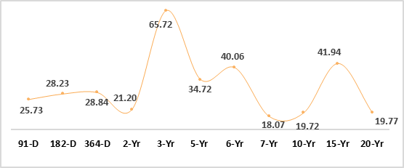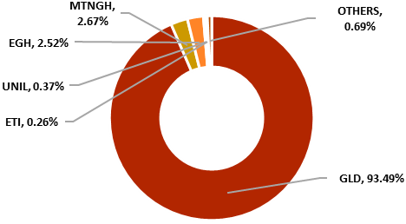

**GSE Contributors to Value**

|  |  |  |  |
| --- | --- | --- | --- |
| **Currency**  **Pairs** | **Midpoint**  **(BoG)** | **Daily∆ (%)** | **YTD∆ (%)** |
| USDGHS | 12.9182 | 0.04 | -8.04 |
| GBPGHS | 16.3157 | -0.27 | -7.25 |
| EURGHS | 14.0061 | -0.18 | -6.28 |
| CNYGHS | 1.7855 | 0.03 | -6.29 |
| ZARGHS | 0.6925 | 0.04 | -6.22 |

**Currency Movement**

Upcoming Events:

* 12th April: **MTNGH** Final Dividend Payment Date.

* GDP Growth Q423 – 3.8%
* Interbank Int. Rate – 28.58%

* MPR – 29.0%
* Inflation – 23.2%

Macroeconomic Indicators:

8th APRIL 2024

**MORNING BRIEF**

Disclaimer - SIC Brokerage and its employees do not make any guarantee or other promise as to any results that may be obtained from using our content. No one should make any investment decision without first consulting his or her own Investment advisor and conducting his or her own research and due diligence. SIC Brokerage disclaims any and all liabilities in the event that any Information, commentary, analysis, opinions, advice and/or recommendations prove to be inaccurate, incomplete or unreliable, or result in any investment or other losses.